**Observations:**

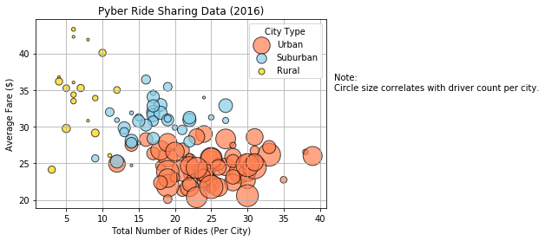

1. One observation to take away from this image is how many rides take place within urban areas compared to rural ones.

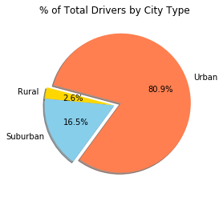

1. Due to the larger amount of fares awarded within urban areas, it’s also not surprising to see how approximately 81% of drivers work within those areas as well. It makes sense that individuals would work in an area that provides themselves with the highest potential for income.

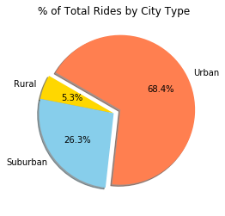

1. However, it is also important to recognize that over 25% of requested rides still come from suburban environments. Given urban areas, this figure isn’t too unrealistic due to the fact that it can be cost productive to ride into a city rather than having to incur parking prices yourself.